Practical 3

1) Write a bash script to calculate the sum of n inputs.

Code:
#!/bin/bash

sum=0

echo "Enter the number of inputs (n):"
read n

echo "Enter $n numbers:"

for ((i = 1; i <= n; i++)); do
echo -n "Enter number $i: "
read num
sum=$((sum + num))
done

echo "Sum of $n numbers is: $sum"

Output:
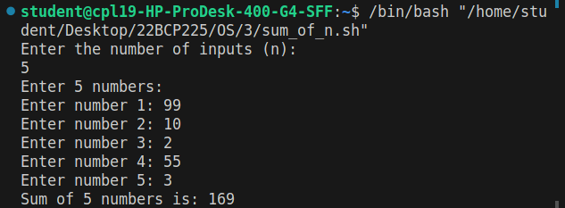

2) Write a bash script to find the largest out of three numbers.

Code:
#!/bin/bash

echo "Enter three numbers:"

read -p "Enter number 1: " num1
read -p "Enter number 2: " num2
read -p "Enter number 3: " num3

largest=$num1

if [ $num2 -gt $largest ]; then
largest=$num2
fi

if [ $num3 -gt $largest ]; then
largest=$num3
fi

echo "The largest number is: $largest"

Output:
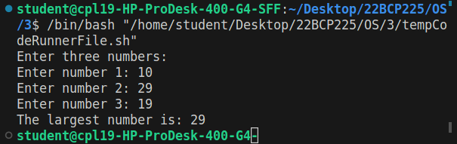

3) Write a menu driven bash script for the following operations.

a. Display calendar of current month
b. Display today’s date information
c. Display the username of the users currently logged in
d. Display the username at given coordinates
e. Display the terminal number

Code:
#!/bin/bash

echo "Main Menu"
echo "1. Display calendar of current month"
echo "2. Display today’s date information"
echo "3. Display the username of the users currently logged in"
echo "4. Display the username at given coordinates"
echo "5. Display the terminal number"
echo "6. Exit"
echo -n "Enter your choice: "
read choice
case $choice in
1) cal ;;
2) date ;;
3) who ;;
4)
read -p "Enter X position: " x
read -p "Enter Y position: " y
tput cup $x $y
echo -n $USER
;;
5) tty ;;
6) exit ;;
*) echo "Invalid choice" ;;
esac

Output:
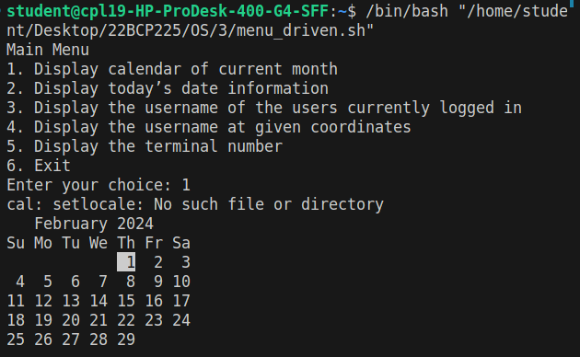
4) Write a bash script to get first n Fibonacci numbers.

Code:
#!/bin/bash

echo "Enter the value of n:"
read n

# Initialize the first two Fibonacci numbers
a=0
b=1

echo "First $n Fibonacci numbers:"

for ((i = 1; i <= n; i++)); do
echo -n "$a "

# Calculate the next Fibonacci number
next=$((a + b))

# Update values for the next iteration
a=$b
b=$next

echo " "
done

Output:
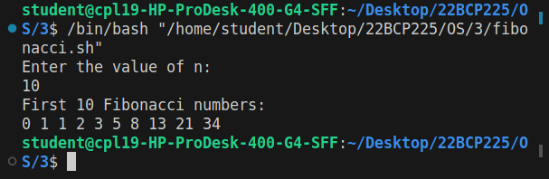

5) Write a bash script to check whether the given year is a leap year.

Code:
#!/bin/bash

echo "Enter a year:"
read year

if [ $((year % 4)) -eq 0 ] && [ $((year % 100)) -ne 0 -o $((year % 400)) -eq 0 ]; then
echo "$year is a leap year."
else
echo "$year is not a leap year."
fi

Output:
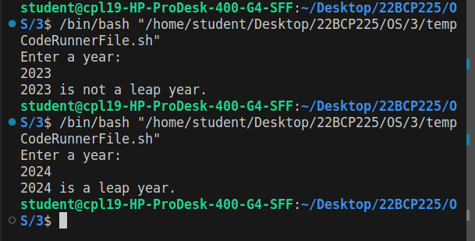
6. Write a bash script to print a number triangle

Code:
#!/bin/bash
read -p "Enter the number of rows: " num

for ((i = 1; i <= num; i++)); do
for ((j = 1; j <= i; j++)); do
echo -n "$i "
done
echo ""
done

Output:
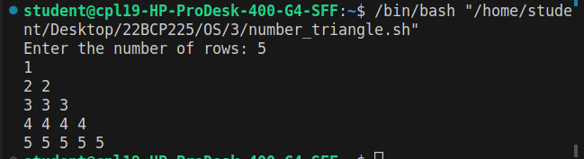
7. Write a bash script to change the input to uppercase

Code:
#!/bin/bash
read -p "Enter a string: " input
uppercase=${input^^}
echo "Uppercase: $uppercase"

Output:
